Boolean to Logic Gates and Simplifications

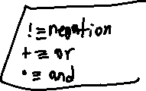

1. (!A + !B)(!A + B) (simplify a boolean equation)

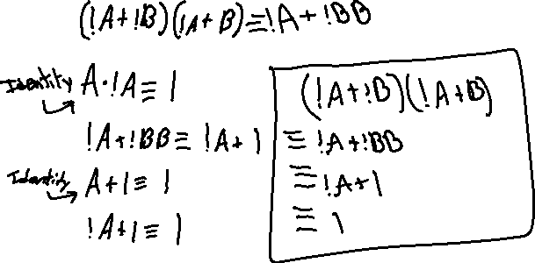

2. A + BC + !D (draw a logic circuit)

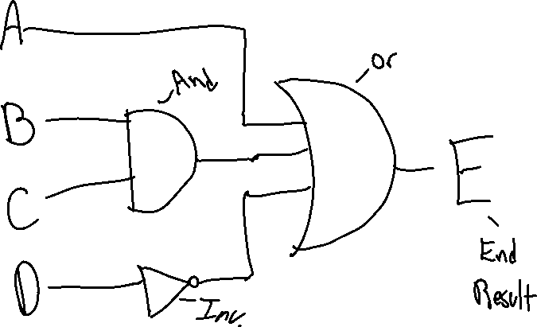

3. AB + !(AC) (draw a logic circuit)

